# **15 - PostgreSQL 17 Performance Tuning: Index Scans vs. Index-Only Scans**

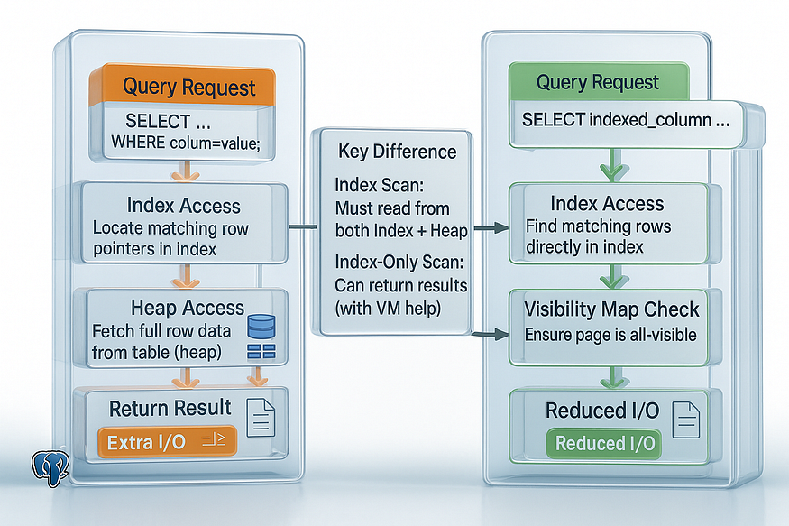

So far, we have looked at how indexes work and when PostgreSQL chooses Index Scans or Bitmap Scans. But there’s more to indexing: sometimes PostgreSQL can avoid reading the table at all.

This is where ****Index-Only Scans**** come in. Let’s explore the difference with a practical demo.

## **Index-Only Scans in PostgreSQL — A Deep Dive**

## **What are Index-Only Scans?**

An ****Index-Only Scan (IOS)**** is a powerful optimization in PostgreSQL where the database engine can answer a query ****entirely from the index****, without having to fetch the original row data from the table (the heap). This works when the index contains all the columns needed to satisfy the query.

The benefit is simple but profound: ****fewer disk reads, fewer buffer accesses, and faster queries.**** Since table pages are often much larger and scattered, avoiding them can yield massive performance gains.

## **Why Index-Only Scans Are Faster**

* ****Skip the heap reads:**** Traditional index scans still need to check the table (heap) to fetch requested columns and confirm row visibility. IOS can skip this if the index already has the data.
* ****Compact and cache-friendly:**** Indexes are smaller than the table and more likely to fit in memory. Scanning only the index reduces random I/O.
* ****Faster queries with limits:**** When combined with ORDER BY and LIMIT, IOS can return results quickly without scanning large portions of the table.

In short: ****the less PostgreSQL touches the heap, the faster your query runs.****

## **The Two Key Conditions for IOS**

1. ****All required data is in the index****

* Every column in the SELECT, WHERE, ORDER BY, or GROUP BY clause must come directly from the index.
* PostgreSQL allows you to add extra non-key columns using INCLUDE in an index definition (known as a *covering index*).

Example:

CREATE INDEX idx_products_category_cover ON products (category) INCLUDE (product_id, price);

2. Here, the index stores category for filtering and includes product_id and price for retrieval.

1. ****Visibility map marks the rows as all-visible****

* PostgreSQL uses MVCC (multi-version concurrency control). It must ensure a row is visible to your query snapshot.
* Normally, this requires a heap fetch.
* With the ****Visibility Map (VM)****, PostgreSQL knows if a whole heap page contains only visible rows. If so, no heap fetch is needed.
* If the VM doesn’t confirm this, PostgreSQL falls back to heap lookups even though the plan still says “Index Only Scan.”
* Hint: Run VACUUM regularly (or rely on autovacuum) so the visibility map stays updated.

## **How Index-Only Scans Work (Step-by-Step)**

1. PostgreSQL traverses the index to locate entries matching the filter condition.
2. For each entry, it consults the visibility map:

* If marked ****all-visible****, PostgreSQL skips the heap entirely.
* If not, PostgreSQL fetches the row from the heap for verification.

1. If the needed columns are included in the index, PostgreSQL returns them directly.
2. If there’s an ORDER BY that matches the index order, results come out sorted without extra work.
3. If the query uses LIMIT, PostgreSQL can stop once enough rows are found.

## **Example Walkthrough**

Suppose we want to quickly fetch product IDs and prices for products in a given category.

CREATE INDEX idx_products_category_cover  
ON products (category)  
INCLUDE (product_id, price);

postgres=# CREATE INDEX idx_products_category_cover  
ON products (category)  
INCLUDE (product_id, price);  
CREATE INDEX  
postgres=#

EXPLAIN (ANALYZE, BUFFERS)  
SELECT product_id, price  
FROM products  
WHERE category = 'Category_2';

A good plan might look like:

postgres=# EXPLAIN (ANALYZE, BUFFERS)  
SELECT product_id, price  
FROM products  
WHERE category = 'Category_2';  
 QUERY PLAN  
-------------------------------------------------------------------------------------------------------------------------------------------------------------  
 Index Only Scan using idx_products_category_cover on products (cost=0.56..44995.00 rows=972711 width=19) (actual time=0.023..721.391 rows=1000000 loops=1)  
 Index Cond: (category = 'Category_2'::text)  
 Heap Fetches: 0  
 Buffers: shared hit=7151  
 Planning Time: 0.065 ms  
 Execution Time: 1333.884 ms  
(6 rows)  
  
postgres=#

Key observations:

* ****Index Only Scan**** → PostgreSQL used the index without touching the heap.
* ****Heap Fetches: 0**** → All rows came from the index, thanks to the visibility map.
* Execution time is extremely low compared to a table scan.

## **When Index-Only Scans Shine**

* ****Large tables with selective queries****: Avoiding heap fetches saves thousands or millions of I/O operations.
* ****Reporting dashboards and APIs****: Frequent lookups that return a small number of columns.
* ****Queries with ORDER BY and LIMIT****: Results can be returned very quickly from the index.
* ****Covering indexes****: When you design indexes to include frequently accessed columns.

## **When They May Not Help**

* ****Small tables****: Sequential scans can be just as fast.
* ****Frequent updates****: Updated/deleted rows delay pages becoming all-visible, forcing heap fetches.
* ****Queries needing non-indexed columns****: PostgreSQL still must visit the heap.
* ****Indexes with too many included columns****: Bloated indexes slow down writes and increase storage use.

## **Best Practices for Effective IOS**

* Use ****covering indexes**** with INCLUDE for common queries.
* Keep autovacuum active to maintain the visibility map.
* Avoid excessive updates to indexed columns (prefer HOT updates).
* Don’t over-cover: balance read performance with write costs.
* Regularly verify with:

EXPLAIN (ANALYZE, BUFFERS) ...

* Look for Heap Fetches: 0.

Index-Only Scans in PostgreSQL are a performance booster that let the database serve results ****directly from the index**** without consulting the heap — provided the index has all the required columns and the visibility map confirms row visibility. They’re especially powerful for large datasets, reporting queries, and queries with limits. With careful index design and good autovacuum practices, they can cut query times dramatically.

## **1. The Difference Between Index Scan and Index-Only Scan**

Suppose we query like this:

SELECT product_id, product_name   
FROM products   
WHERE product_id = 10;

postgres=# SELECT product_id, product_name  
FROM products  
WHERE product_id = 10;  
 product_id | product_name  
------------+--------------  
 10 | Product_10  
(1 row)  
  
postgres=#

If there is an index on product_id, PostgreSQL does two things:

1. Looks up the row location in the index.
2. Fetches the full row from the table (heap) to get the additional columns.

👉 This is a normal ****Index Scan****. It always needs to touch both the index and the table.

But what if we only select columns that already exist inside the index? Then PostgreSQL doesn’t need to touch the table at all — it can return results directly from the index. This is called an ****Index-Only Scan****.

## **2. Create the Products Table with 10 Million Rows**

For the demo, let’s create a large products table:

CREATE TABLE products (  
 product_id BIGSERIAL PRIMARY KEY,  
 product_name TEXT,  
 category TEXT,  
 price NUMERIC,  
 stock_qty INT  
);

postgres=# CREATE TABLE products (  
 product_id BIGSERIAL PRIMARY KEY,  
 product_name TEXT,  
 category TEXT,  
 price NUMERIC,  
 stock_qty INT  
);  
CREATE TABLE  
postgres=#

-- Insert 10 million rows  
INSERT INTO products (product_name, category, price, stock_qty)  
SELECT   
 'Product_' || g,  
 'Category_' || (g % 10),  
 (random()*500)::NUMERIC,  
 (random()*100)::INT  
FROM generate_series(1, 10000000) g;  
ANALYZE products;

postgres=# -- Insert 10 million rows  
INSERT INTO products (product_name, category, price, stock_qty)  
SELECT  
 'Product_' || g,  
 'Category_' || (g % 10),  
 (random()*500)::NUMERIC,  
 (random()*100)::INT  
FROM generate_series(1, 10000000) g;  
ANALYZE products;  
INSERT 0 10000000  
  
ANALYZE  
postgres=#

## **3. Normal Index Scan**

First, create a simple index:

CREATE INDEX idx_products_id ON products(product_id);

postgres=# CREATE INDEX idx_products_id ON products(product_id);  
CREATE INDEX  
postgres=#

Now run this query:

SELECT * FROM products WHERE product_id = 42;

postgres=# SELECT * FROM products WHERE product_id = 42;  
 product_id | product_name | category | price | stock_qty  
------------+--------------+------------+------------------+-----------  
 42 | Product_42 | Category_2 | 339.575950907242 | 13  
(1 row)  
  
postgres=#

EXPLAIN ANALYZE  
SELECT * FROM products WHERE product_id = 42;

postgres=# EXPLAIN ANALYZE  
SELECT * FROM products WHERE product_id = 42;  
 QUERY PLAN  
---------------------------------------------------------------------------------------------------------------------------  
 Index Scan using idx_products_id on products (cost=0.43..8.45 rows=1 width=49) (actual time=1.665..1.667 rows=1 loops=1)  
 Index Cond: (product_id = 42)  
 Planning Time: 1.170 ms  
 Execution Time: 1.687 ms  
(4 rows)  
  
postgres=#

****What happens:****

* PostgreSQL uses an ****Index Scan****.
* It finds the row quickly via the index, but then still fetches the full row from the table.
* Two lookups per result row (index + heap).

## **4. Index-Only Scan**

Now try a query that selects only the indexed column:

EXPLAIN ANALYZE  
SELECT product_id FROM products WHERE product_id = 42;

postgres=# EXPLAIN ANALYZE  
SELECT product_id FROM products WHERE product_id = 42;  
 QUERY PLAN  
-------------------------------------------------------------------------------------------------------------------------------  
 Index Only Scan using idx_products_id on products (cost=0.43..4.45 rows=1 width=8) (actual time=0.060..0.062 rows=1 loops=1)  
 Index Cond: (product_id = 42)  
 Heap Fetches: 0  
 Planning Time: 0.090 ms  
 Execution Time: 0.076 ms  
(5 rows)  
  
postgres=#

****What happens:****

* PostgreSQL uses an ****Index-Only Scan****.
* Since all the needed data (product_id) is already inside the index, PostgreSQL skips the table.
* Much faster, because it avoids heap access.

## **5. Covering Index with**INCLUDE

What if queries often fetch ****one filter column and one extra column****?

Example:

EXPLAIN ANALYZE  
SELECT product_name, price FROM products WHERE product_id = 42;

postgres=# EXPLAIN ANALYZE  
SELECT product_name, price FROM products WHERE product_id = 42;  
 QUERY PLAN  
-------------------------------------------------------------------------------------------------------------------------  
 Index Scan using products_pkey on products (cost=0.43..8.45 rows=1 width=26) (actual time=0.033..0.034 rows=1 loops=1)  
 Index Cond: (product_id = 42)  
 Planning Time: 4.248 ms  
 Execution Time: 0.091 ms  
(4 rows)  
  
postgres=#

Normally, PostgreSQL would still fetch from the heap, because product_name, priceisn’t in the index.

✅ Solution: Create a ****covering index**** with INCLUDE.

CREATE INDEX idx_products_id ON products(product_id) INCLUDE (product_name, price);

postgres=# CREATE INDEX idx_products_id ON products(product_id) INCLUDE (product_name, price);  
CREATE INDEX  
postgres=#

Now the index contains both:

* Search key → product_id
* Payload → product_name, price

ANALYZE products;

Run again:

EXPLAIN ANALYZE  
SELECT product_name, price FROM products WHERE product_id = 42;

postgres=# EXPLAIN ANALYZE  
SELECT product_name, price FROM products WHERE product_id = 42;  
 QUERY PLAN  
--------------------------------------------------------------------------------------------------------------------------------  
 Index Only Scan using idx_products_id on products (cost=0.43..4.45 rows=1 width=26) (actual time=0.018..0.020 rows=1 loops=1)  
 Index Cond: (product_id = 42)  
 Heap Fetches: 0  
 Planning Time: 0.059 ms  
 Execution Time: 0.036 ms  
(5 rows)  
  
postgres=#

👉 PostgreSQL can now return results with an ****Index-Only Scan**** because both columns are available in the index itself.

## **Key Takeaways**

* ****Index Scan**** → always fetches the row from the table after finding it in the index.
* ****Index-Only Scan**** → returns data directly from the index if all requested columns are present there.
* ****Covering Indexes (INCLUDE)**** let you add extra payload columns so more queries can benefit from Index-Only Scans.
* Since PostgreSQL 11, INCLUDE makes Index-Only Scans even more powerful for real-world queries.

✅ Index-Only Scans can significantly reduce I/O and speed up queries, especially on large tables like our products table with 10 million rows.